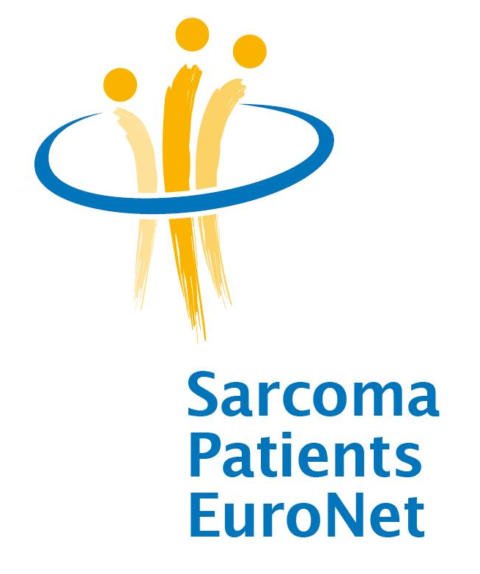

Conference Report

2nd SPAEN Annual Conference for Organizations
Representing Patients With Sarcomas,
GIST or Desmoid-Tumours
17. - 19. November 2011
andel’s hotel, Berlin/Germany

“A Better Future For Patients With A Rare Cancer!”

Acknowledgements

We would like to thank the following sponsors who are supporting the
SPAEN Annual Conference 2011 with an unrestricted grant:

Bayer, GSK, MSD/Merck, Novartis, Pfizer, PharmaMar, Takeda

At the request of the Board of Directors, SPAEN received equal grants from these Sustaining Partners. This funding is not related to any objectives of SPAEN or any objectives/content of the SPAEN Annual Conference. The idea, conception, planning, preparation, realisation, management and the summary of the SPAEN Conference 2011 was in the responsibility of SPEAN without any influence from the sponsors/funders. SPAEN is an independent European network of patient advocacy groups – without commercial influence. The SPAEN funding policy is based on our “Code of Practice”.

We are looking forward to continuing these partnerships on our way to creating
“A Better Future For Patients With A Rare Cancer!”

Introduction

Sarcoma Patients EuroNet e.V./Assoc. (SPAEN), the European Network of Sarcoma, GIST and Desmoid patient advocacy groups, was founded in April 2009 with the aim of extending information services, patient support and advocacy to patient organisations for the benefit of sarcoma patients across the whole of Europe. Acting in partnership with clinical experts, scientific researchers, industry and other stakeholders, SPAEN is working to improve the treatment and care of sarcoma patients in Europe through improving information and support, and by increasing the visibility of sarcomas with policymakers and the public.

More than 80 participants who attended the 2nd SPAEN Annual Conference for organizations representing patients with Sarcomas incl. GIST or Desmoid-Tumours, documented the increasing interest in the disease group of Sarcomas, which is in many European countries a ‘forgotten cancer’, because it is one of the rarest forms of cancer. Among the participants were 55 representatives from Sarcoma Patient Advocacy Groups from 15 countries, several European Sarcoma Experts and industry representatives.

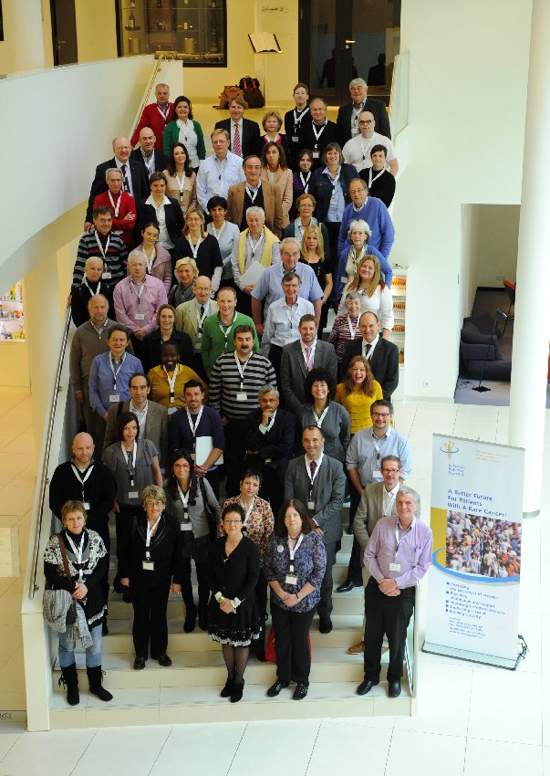
Group picture of the SPAEN Conference Delegates

The meeting focused on research and treatment for Sarcomas and advocacy/capacity building for Sarcoma Patient Advocacy Groups. The main aims of the conference were supporting patient advocates to acquire new skills and knowledge about the diagnosis and treatment of Sarcomas. Leading European Sarcoma Experts joined the conference to provide latest medical updates on treatment options and clinical trials in Sarcomas. Furthermore the conference aimed to foster networking across borders between patient group representatives, as well as sharing best practice to enhance their daily work as patient advocates.
Impressions from Conference Delegates and Faculty

Hans Keulen, Chordoma Foundation, US
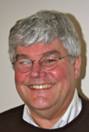
“It is a strange experience to see so many people with a life threatening disease interact so strong with physicians, scientists and representatives of pharma. Not for their own benefit, but for the benefit of other patients and especially for the next generation of patients. The SPAEN conference illustrates that the best way for small patient organizations of rare cancers to get their voices heard by scientists, physicians and industry is to unite at the highest possible level: Europe. That is exactly what SPAEN is trying to do and what is proving to be increasingly effective."
Frode Homb, Sarkomer Norway, Norway
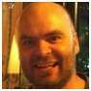
“Compared with other types of cancer, sarcomas are very rare. In my country only about 200 new cases of sarcomas occur each year. Bringing sarcoma patient organizations from all of Europe together under an umbrella such as SPAEN, and unite all of our sarcoma and GIST patient voices in to one, and speak with strength towards the states in Europe and international research community, is the only true way to raise public and scientific awareness of sarcomas, GIST and desmoid tumours. SPAEN could be the tool that could ensure an early accurate diagnosis and earlier start of the right treatment for sarcoma, GIST and desmoid patients. And if this is not a good enough reason to be united; I will mention the economic turmoil raising now in Europe. In times of economic decline, the weakest among us all, patients and the sick, always suffer most. They could lose life quality and could also lose the dearest thing of all. Cuts in government spending on health care, more and more private welfare, and a decrease of spending on science and research on cancer, is one of the mistakes a state and society can make. If there is a time we all must speak with one voice, it is now!”
PD Dr. Peter Reichardt, Sarcoma-Center Berlin-Brandenburg, Germany
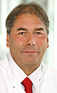
“It is always a great pleasure and honour to speak at the SPAEN meetings, to exchange thoughts and ideas, and to meet patients and advocates who are so devoted to education of sarcoma patients around Europe.”

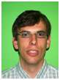
Corneel Coens, EORTC Quality of Life Department, Belgium
“The SPAEN 2011 meeting in Berlin was my first major direct interaction with patient advocacy groups. I did not know what to expect, but was positively surprised by the reactions. There was an incredible hunger for knowledge in the audience. It is clear that the participants were there with a strong desire to inform other people as well as be informed by others. The questions I received revealed the variety of needs, backgrounds, experiences and challenges of those present.”
Ellen van Arem de Haas, Contactgroep GIST Nederland - Belgie
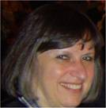
“It was really great to meet familiar people again, and to meet the representatives of new groups as well. SPAEN gives you the distinct feeling that, although sarcomas are most times very rare and thus organizations are rather small in their respective countries, we are one big family. A family seeking for the best understanding and the best treatments particularly in Europe, but also far beyond the European borders. Being part of SPAEN we are not keeping our knowledge and good practices behind our own doors, but we are looking over the hedges to our neighbouring countries in the whole of Europe and are very willing to share all with all. That's what makes SPAEN very valuable. Being at Berlin, at the first time of my life, I immediately felt at home. Why? Because I finally understood what the late American president meant all those years ago in 1963, when I was only 4 years old. When he stood there in Berlin, stating: 'Ich bin ein Berliner'. We, gathered at SPAEN, we are all Berliners. Hard working, dedicated to build a better future, speaking with one strong voice, in aid of obtaining the very best for our patients.”
PD Dr. Bernd Kasper, UMM Mannheim, Germany
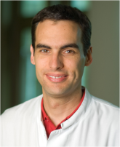
“SPAEN 2011 was a great experience for me. It is so beneficial to bring patients, experts and industry together. I was really impressed by the patients’ knowledge about their disease and I was touched by the enthusiastic work of the different advocacy groups around Europe. I will be more than happy to support SPAEN in the future.”
Cameron Burry, Merseyside and Cheshire Sarcoma Support/Sarcoma UK
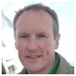
“The Conference clearly illustrated the value and power from pooling the ideas and energies of our national organisations. I'm sure all attendees have been re-energised, and will have taken away new ideas to improve the patient experience and outcome in their own territories.”

Markus Wartenberg, Das Lebenshaus (DE) and SPAEN Board Member
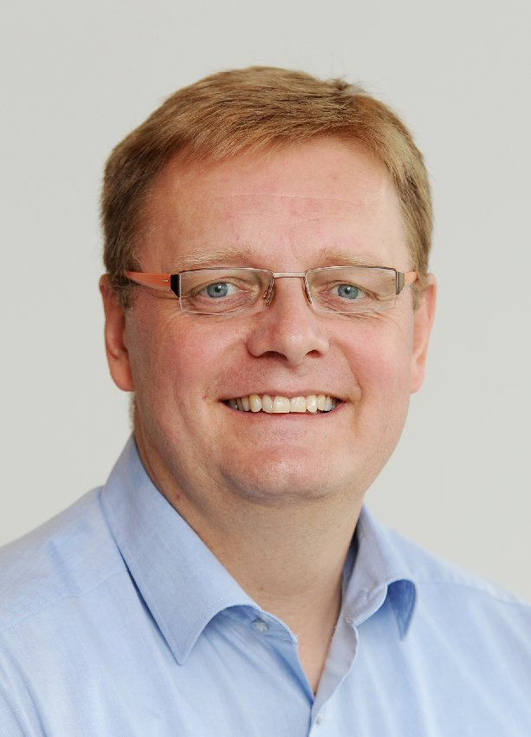
“The future of improving treatment and better tailored research for Sarcomas will depend on a very close cooperation between all stakeholders. This Conference shows very clear again, that Sarcoma groups in Europe are very motivated to work hand in hand together. But it demonstrates also, that SPAEN as the European voice of all Sarcoma, GIST and Desmoid patient advocacy groups is becoming a peer to peer partner to the European Experts and the Healthcare Industry.”

Day 1 – Research Day (Thursday, November the 17th 2011)

Roger Wilson, SPAEN President and Markus Wartenberg (SPAEN Industry Relations) opened the 2nd SPAEN Conference and welcomed all attendants in Berlin.

Pfizer and Bayer HealthCare, having their headquarters in Berlin, started the programme with two key note speeches on research & development. These presentations covered not single agents or upcoming therapies in the field of Sarcomas. Both speeches illustrated how oncology is changing and what the research-philosophies of both companies are.

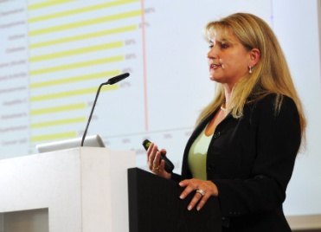
Dr. I. Marondel, Director Strategic Alliances, Pfizer Oncology Germany, explained the research strategy of Pfizer Oncology and expressed the company’s commitment to the cancer and sarcoma patient community. She described Pfizer’s mission to develop biomarker-guided treatment strategies such as the development of Crizotinib in lung cancer. One fundamental strategy in developing new therapies is molecular testing on tumour specimens which can be performed through close collaborations including public and private partnerships with research institutions, societies and organisations. Pfizer’s vision can be summarized as advancing the science “to deliver the right drug at the right time for the right patient”.
Dr. I. Marondel, Pfizer Oncology Germany

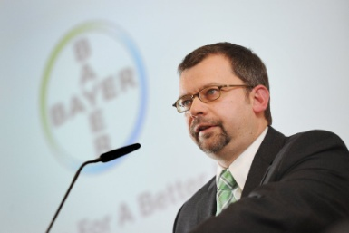
Dr. D. Laurent, Global Clinical Development Oncology, Bayer HealthCare Pharmaceuticals, Germany asked the question what the patient community can expect from Bayer and explained their strategy and commitment of entering the field of oncology and especially sarcoma and GIST. “Science for a better life” summarizes Bayer HealthCare’s mission. As described above, Bayer HealthCare also integrates external innovations in their oncology strategy through cooperation with research partners such as the German Cancer Research Centre in Heidelberg.
Dr. D. Laurent, Bayer Healthcare Pharmaceuticals

Both speakers illustrated that the topic „Personalised Medicine” is leading to the fact, that pharmaceutical companies are doing more research and development in Rare Cancers today and in the future than in previous years.

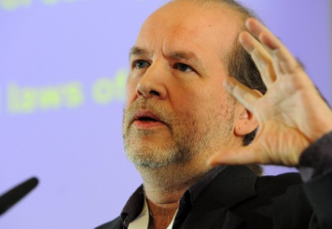
The future design of clinical trials was the topic of the second half of the day. Two representatives from the European Organisation for Research and Treatment of Cancer (EORTC) in Brussels, Dr. J. Bogaerts from the Statistical Department and C. Coens from the Quality of Life Group, addressed these topics. Basic definitions and aspects of statistical work in a clinical study (endpoints, hypothesis testing, p value etc.) with a focus on clinical trial design were explained. Techniques such as randomisation and blinded assessment are key tools to avoid a statistical bias and get valid and objective results. Recently, the choice of certain endpoints such as progression-free survival (PFS) as a primary endpoint, patient related outcomes and biomarker-driven study designs became more important and will be essential in understanding the results in future sarcoma trials.
Dr. J. Bogaerts, EORTC

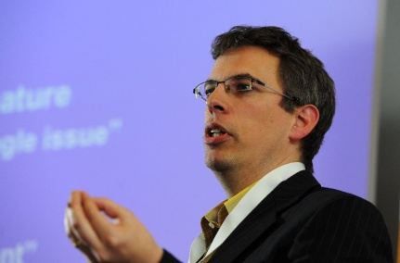
Furthermore, Corneel Coens from EORTC presented aspects of quality of life and their possible implementation as a future endpoint in clinical trials. However, it was pointed out how difficult it is to measure objectively certain items and aspects of quality of life. One example of a basic quality of life questionnaire for tumour patients is the EORTC QLQ-C30 which consists of only 30 questions.
C. Coens, EORTC
The Soft Tissue and Bone Sarcoma Group (STBSG) of the EORTC has already addressed the described issues and, for example, implemented PFS as a primary endpoint in their trials. Moreover, a separate Quality of Life Group at the EORTC was funded and each study protocol will be reviewed and advised by this group asking specific questions regarding aspects of quality of life.

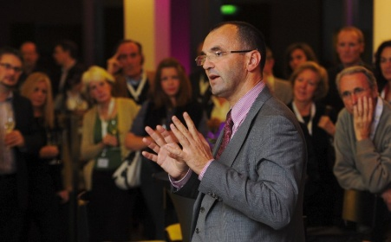
After the official programme an internal dinner for all conference delegates at the skycafe high up in the 12th floor of andel’s hotel rounded off the day and delegates had the opportunity to discuss and exchange in a relaxed atmosphere. Prof. Dr. Jean Yves Blay, the current EORTC president and chair of the SPAEN Medical Advisory Board, gave a short Key Note Lecture and talked about the future roles of the “Sarcoma League” following Conticanet and the “World Sarcoma Network” as examples of broad networks offering the chance of running clinical trials on a worldwide basis in extremely rare sub entities.
Prof. Dr. J.Y. Blay

Day 2 – Treatment Day (Friday, November the 18th 2011)

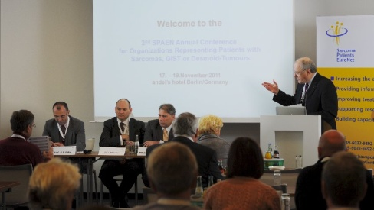
The treatment day began with a Questions & Answers session to a European Sarcoma Expert Panel. The panellists were Prof. J. Y. Blay (Université Claude Bernard in Lyon, France), Dr. D. Strauss (Royal Marsden Hospital, UK) and PD Dr. P. Reichardt (Sarcoma-Center Berlin-Brandenburg, Germany) giving the audience the possibility to ask questions for a better understanding of sarcomas.

One of the issues debated was the treatment of uterine sarcomas. The question from the audience was based on the perception that these are the most frequently mistreated sarcomas. The panel broadly agreed and considered the reasons this was an accurate description. How matters could be improved was indicated as a topic for joint action between clinical experts and patient advocacy groups. The topic was further discussed in the sarcoma group later in the day.

This introductory session was followed by a closer look at surgery of retroperitoneal sarcomas from Dr. D. Strauss (Royal Marsden, London) and prosthetic replacement for bone sarcomas from Dr. L. Jeys (The Royal Orthopaedic Hospital, Birmingham). Both gave a detailed insight into the challenges these tumours offer the surgeon, and a clear message was that expertise is critical to a good outcome for the patient.

The afternoon was split into three parallel sessions: on GIST (therapy management and compliance, paediatric GIST, new treatment options), Sarcomas (management of advanced sarcomas, new agents and clinical trials) and Desmoids (molecular genetics, treatment options and clinical trials). This format of parallel sessions was very well received by the participants giving them the opportunity to learn and discuss in smaller, disease-specific groups.

In the Educational session on sarcoma with presentations from Prof. J. Y. Blay, Dr. L. Jeys, Prof. M. Schwarzbach and PD Dr. P. Reichardt as well as in the session on GIST with presentations from Prof. F. Haller, Dr. R. Bulusu and PD Dr. P. Reichardt the management strategies of treating advanced sarcomas and GIST patients were presented with a special focus on new treatment options, agents and clinical trials.

The highlight of the year 2011 in GIST was the ASCO presentation of the results of the German‐Scandinavian study (SSG/AIO) on adjuvant treatment with imatinib in high risk GIST patients. 400 patients were enrolled between February 2004 and September 2009. Patients were assigned to receive adjuvant therapy for either one year or three years. After a median follow‐up of 54 months in the one year imatinib arm 60% of patients were free from disease progression, versus 87% of patients who survived progression free who received 3 years of treatment with imatinib, and the difference in progression free survival (PFS) for those with longer treatment was highly significant (p < 0.0001). But what was even more striking, that this PFS benefit was also reflected in overall survival, with 92 % of patients included in the 3‐year surviving after 5 years, versus 82% of the patients who received adjuvant imatinib for the 1 year (p = 0.019). This trial will undeniably change a therapeutic standard, as this now establishes that high risk GISTs need to receive 400 mg/day of imatinib as adjuvant treatment for a minimal duration of three years.

In the advanced and metastatic setting in GIST, a number of new generation tyrosine kinase inhibitors are in clinical trials, such as masitinib, dasatinib, sorafenib and regorafenib. regorafenib showed promising results in the phase II trial with the longest ever reported PFS of 10 months for imatinib and sunitinib resistant GIST patients. The phase III study (GRID) has already finished recruitment, and results will be hopefully presented in the second half of 2012.

Next, an integrated workshop focused on professional side effect management as an essential tool to assist treatment compliance in GIST patients. Finally, there was a talk on the rare paediatric and Wild Type GIST, which was described to highlight the differences to the commoner and better understood cases of GIST with known mutations. The research coming out of the National Institute of Health in the USA was discussed, and the development of a similar Paediatric and Wild Type GIST expert network in Europe was discussed.

For soft tissue sarcomas, two new compounds were presented at the 2011 ASCO meeting being tested in large phase III clinical trials: Pazopanib (from GSK - brand name in Kidney Cancer = Votrient®) is a VEGF, PDGF and KIT inhibitor. The randomized study (PALETTE) compared pazopanib with a placebo (randomisation 2:1, with no cross‐over). 369 patients (pre‐treated by anthracyclines) were included between 2008 and 2010. Grade 3 toxicities of pazopanib were mainly fatigue (13%), diarrhoea (5%) and hypertension (7%). In the pazopanib arm, PFS could be increased from 7 to 21 weeks (p > 0.0001). This study is the first global study led in sarcomas that scientifically demonstrated anti‐tumour efficacy of anti‐angiogenic factors targeting VEGFR.

Ridaforolimus (from Ariad/MSD/Merck, AP23573, Ariad), an mTOR inhibitor, was the second promising compound being tested in a phase III trial (SUCCEED). This was the very first study assessing a targeted therapy as maintenance treatment in non‐progressive patients after receiving conventional chemotherapy. 711 patients were included. The median PFS showed a significant increase of 3.1 weeks by independent reviewers without any significant impact on survival. All histological subgroups benefit from ridaforolimus. 61% of the patients included in the therapeutic arm developed mucositis.

No doubt, there is an increasing number of promising new agents being developed for advanced and/or metastatic soft tissue sarcomas that will certainly improve the results of this patient group. At the end of the sarcoma track short profiles of three rare, distinct sarcoma subtypes, chordoma, uterine leiomyosarcoma and retroperitoneal sarcoma, and their characteristics, possible treatment strategies and implications were presented.

The Educational on desmoid tumors with presentations from Dr. A. Neuville (Institut Bergonié, France), Dr. D. Andreou (Sarcoma Center Berlin-Brandenburg, Germany) and PD Dr. B. Kasper (UMM Mannheim, Germany) focused on the diagnosis and treatment of this extremely rare and difficult to treat subgroup of soft tissue sarcomas. Starting with basics about diagnosis, clinical presentation and molecular pathology of desmoids, the different treatment options including surgery, radiotherapy and systemic therapy as well as possibilities of functional imaging were discussed. Due to the heterogeneity of desmoids and their often unpredictable clinical course, there is no established standard of care for this disease affecting especially young female patients between 30 and 35 years. On the molecular level, desmoids are characterized by mutations in the beta-catenin gene, CTNNB1, or the Adenomatous Polyposis Coli (APC) gene. The proof of a CTNNB1 mutation may be useful when the pathological differential diagnosis is difficult and the location of the mutation might be predictive for disease recurrence. Therefore, the mutation status of the beta-catenin gene, CTNNB1, may be used to guide the therapeutic management comprising surgical resection, medical treatment and observation.

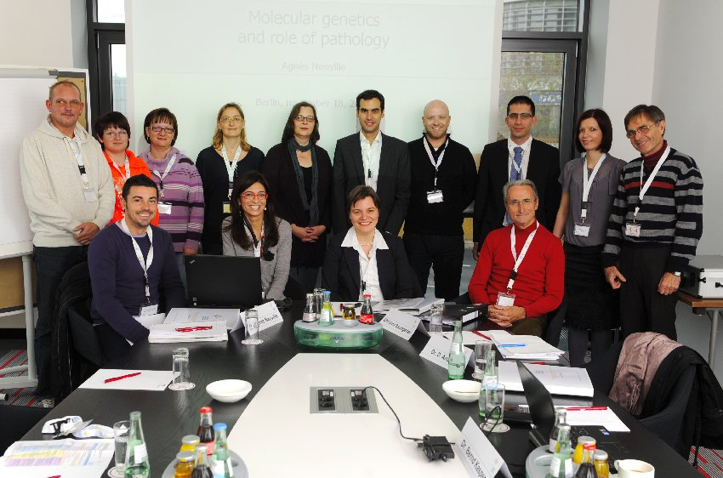
Taken together, treatment needs to be individualized to optimize local tumor control and the preservation of patients’ quality of life. The application of a multidisciplinary assessment with multimodality treatment forms the basis of care for these patients. Watchful waiting may be the most appropriate management in selected asymptomatic patients. Functional imaging methods like positron emission tomography (PET) could possibly be used to predict the biological behavior of desmoid tumors as well as for the monitoring of the therapeutic management. Current and upcoming clinical trials were presented demonstrating that there is an absolute unmet medical need for prospective and randomized clinical trials in this rare disease. An EORTC study project evaluating the efficacy of regorafenib versus liposomal doxorubicin in advanced / refractory desmoid tumor patients in a randomized setting is currently on the way.
Desmoid Group with patient group representatives and experts

After a long day full of information the social evening program was a welcome change for all participants. The group took a short bus tour through Berlin with the chance to see the most important sights of Berlin. After the sightseeing tour the group finished off the evening with a typical Berlin dinner at the Spandau Brewery.

Day 3 – Advocacy Day (Saturday, November the 19th 2011)

After two days of presentations the advocacy day aimed to be more interactive by giving the participants the opportunity to discuss and share certain topics in smaller workgroups. During the two round table discussions focussing on the access to clinical excellence (national needs, problems and challenges in terms of medical issues and treatment) and advocacy and patient group work, the participants split up in groups of around 10 delegates each to discuss on the topic.

The findings of the discussions were presented in a short summary. Main problems raised in this workshop were difficulties in finding the correct diagnosis, difficulties in finding proper sarcoma centres in each country, lack of patient information and finding ways of communication with new patients.
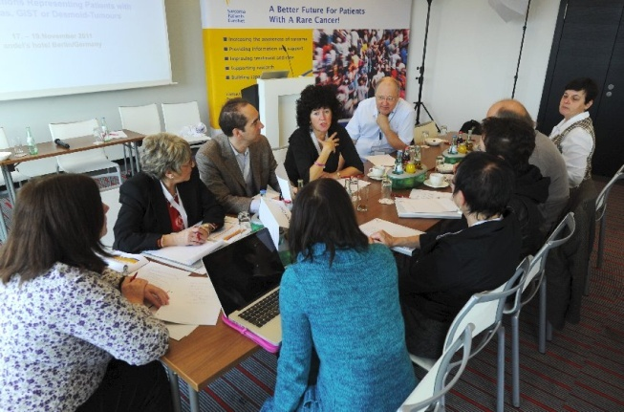
Delegates during round table discussions
The round table discussions were an important and helpful opportunity to establish a consensus about what the agenda and the main focus of SPAEN for the coming years should be. With the input of SPAEN members and other Sarcoma Patient Groups during the round table discussions, strategies will now be developed regarding SPAEN can help with these issues, e.g. providing a list of sarcoma experts or expert centres in the different countries, developing criteria for these expert centres and translating patient information materials in different languages.
In a sharing best practice session SPAEN members presented certain topics and successful projects of advocacy work.

- The making of a GIST Film (GIST Group Switzerland)
Helga Meier Schnorf and Martin Wettstein presented the English trailer of the film “Living with GIST” from the Swiss GIST group. This film shows the way from a correct diagnosis to treatment and dealing with the rare cancer GIST through different patient stories. It is focused on the global networking of patients and physicians and the collaboration of various medical disciplines and research. The focus of all these efforts is the patient. Three patients are talking about their fate, their lives and their cancer journey. The trailer of the film with English subtitles is available on YouTube. The film was awarded a Silver Edi in November 2011 which is a film prize for the best advertising, industrial and corporate films in Switzerland. The film won in the “Corporate: Internal Communication & Training” section.
Congratulations from SPAEN
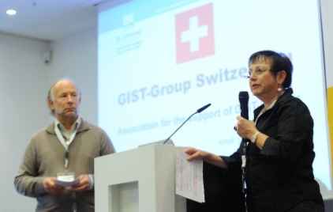
H. Meier Schnorf and M. Wettstein, GIST Group Switzerland
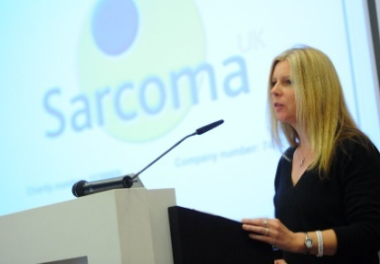
- From support group to national charity – how Sarcoma UK has improved its support for patients by introducing professional staff (Sarcoma UK)
Using the example of Sarcoma UK, Lindsey Bennister (CEO, Sarcoma UK) described the development from a simple support group to a national charity and pointed out that professional structures are essential for successful patient advocacy work. In March 2011, Sarcoma Trust and Sarcoma UK joined and became a new single national charity for sarcoma patients, carers, relatives and healthcare professionals in the UK. With the help of an increased financial support, the development of a new business plan and the recruitment of a professional staff team, new professional structures and systems could be implemented which definitely have led to improvements in the support provided by the charity to patients and their families, as well as increased profile for the charity.
Lindsey Bennister, Sarcoma UK

- Introduction of the newly founded organization Romanian Rare Cancers Association
Darko Emese (Founding member and board member) presented the establishment of the newly founded Romanian Rare Cancers Association. The aim of the association is to represent people affected by rare cancers, their families, organizations and professionals involved in the diagnosis and treatment of rare cancers from Romania. We fight against the ongoing isolation that the health system, mass media, and scientific researchers in our country foster, in order to bring together the efforts specialists, patients, and families affected by rare cancers.
D. Emese, Romanian Rare Cancers Association
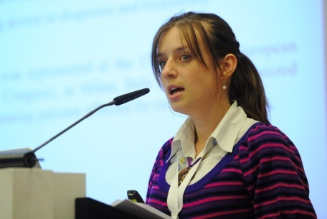
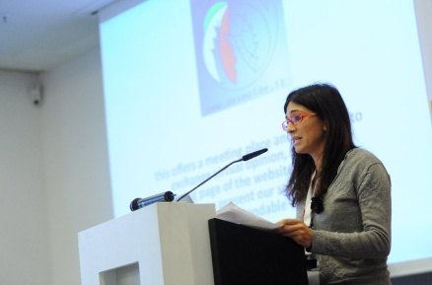
How I started my Desmoid group (Desmoids Italy)
Elisa Baldoin, Founder and President of Desmoids Italy presented how she started her patient group. Desmoids Italy started with a website at www.desmoids.it and offers a virtual meeting place to exchange between patients and caregivers. The website enables patients to compare the way each one is followed from diagnosis to treatment. In addition medical information about Desmoids and current treatment options as well as alternative methods and useful advice such as addresses of experts/centers are provided.
Elisa Baldoin, Desmoids Italy
The objectives of Desmoid Italy are
- To conduct a survey among Desmoid patients to be made available to doctors for further research
- To provide information about Desmoid expert centers in Italy and internationally
- To prepare a “Patient Day” bringing together Desmoid patients and experts
- To collaborate with other Demoid associations and other stakeholders

- The research stimulating efforts of the Chordoma Foundation

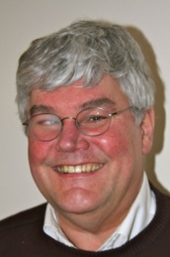
Hans Keulen (European Liaison of the US based Chordoma Foundation) presented on the research stimulating efforts of the the Chordoma Foundation which serve as an excellent example for research stimulating efforts of a patient advocacy group. The Chordoma Foundation was funded in 2007 dedicated to Chordoma, a very rare, slow growing, locally invasive and malignant tumour. In 2007 only one researcher in the US was funded to perform active research on this disease. It was imperative to stimulate research in order to find a real cure. Despite being a small organization with an even smaller budget (??? < 0,5 patients per million the population per year) the Chordoma Foundation managed to increase the number of researchers performing translational and clinical research on Chordoma to over 200 around the globe.
H. Keulen, Chordoma Foundation

The main work of the foundation lies in supporting translational and clinical research on chordoma such as investment in basic research by creating and distributing cell lines, investing in animal models and tissue and creating biobanks. Another main factor for the success of the Chordoma Foundation is its ability of uniting the research community and thus speeding up the flow of information. The examples of research funding of the Chordoma Foundation could certainly serve as a useful and transferable model also for other rare cancers.

- Ways of communication: How you let patients know that you are there to help them (A.I.G. Associazione Italiana GIST)
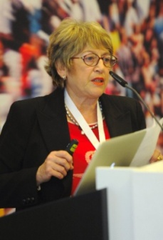
Gabriela Tedone from Associazione Italiana GIST presented ways of communication and ways to reach new patients, as communication with patients and caregivers is the key to success for a patient organisation or advocacy group. Main communication tools are:

- Website & email forum
A good resource is to follow examples from other well established GIST groups.
G. Tedone, A.I.G.
- Regular Newsletters sent by mailing list
Contents: interesting and useful topics, information and advice on common issues, in patient friendly language. Short online surveys inquiring about the audience‘s preferences and suggestions can help to improve communication.
- General and Local patient meetings
In cooperation with Gist expert doctors and with their support, patient meetings are both useful to educate, increase knowledge and confidence as well as to reach out to new patients. Videos can be taken to be published on website and spread information.
- Teleconference / Web conference
Excellent way to use the modern technology to eliminate the geographical distance between patients and Gist experts: direct Q&A sessions with doctors are always very much appreciated.
- Interviews with the experts
On the occasion of events, news, publication of medical papers or in connection with important or controversial topics, it is useful to ask questions of the expert doctors: in this way, medical news becomes more accessible to patients and facilitates their understanding.
- Profitable partnerships
Establishing a good relationship with important cancer and research centers can lead to information on ways for patients to find assistance: for example, we have promoted Mario Negri Institute's existing telephone service on drug interaction among our patients: a great relationship has started for info to Italian GIST patients.

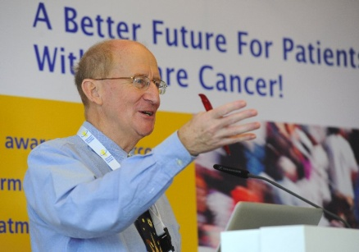
- How we started and how we communicate with our patients (The Sheffield Sarcoma Support Group, UK)
J. Parkinson, Sheffield Sarcoma Support Group
John Parkinson presented on the development of the Sheffield Sarcoma Support Group which serves as an example of focusing on patient communication. It was started in 2009 following an initiative by the Sarcoma Clinical Nurse Specialist in inviting over a hundred sarcoma patients and carers to a discussion meeting. It was agreed that the group would be patient-led and must have a good communication framework focusing on patients’ communication problems. Subsequently, an e-mail address was secured, an e-mail group was set up for newsletter dissemination, a website developed and a leaflet produced. The group wants to help patients to understand more about their sarcoma and draw help, friendship and support from other members of the group, and by a varied programme of talks by the medical staff and discussions with voluntary service groups, as well as having fun with a range of social events from quizzes to dinner-dances.

- Ways to reach new patients and members-only forum (Contactgroep GIST The Netherlands/ Belgium)
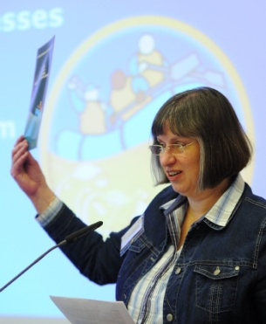
The Contactgroep GIST The Netherlands/Belgium, represented by E. van Arem de Haas (Forum-Newsletter-Web-editor in chief) presented ways of communication and ways to reach new patients as communication with patients and caregivers is the key to success for a patient organisation or advocacy group. The practical advice given included:
E. van Arem de Haas, Contactgroep GIST NL/BE
- You need time to build up and maintain good contacts. Always answer within 1, or at most 2 days.
- Produce an attractive patient brochure and send it by post to all hospitals as well as to GIST-Experts.
- Include experts on your E-mail list and send them your newsletters.
- Use a bit of fun, bright colours, and make sure to provide correct information. Doctors will start to hand out your brochures to patients.
- Begin/build a simple forum, i.e. Wordpress.
- Make sure you are visibly present 24/7.

The SPAEN conference was wrapped up with a short summary, closing remarks and thanks to the presenters and sponsoring partners. SPAEN is looking forward to continuing the partnerships with experts, industry and the sarcoma patient community on the way to creating “A better future for patients with a rare cancer”.

Conclusion & Outlook

There was unanimity amongst delegates that the SPAEN Conference 2011 was a great success. The conference certainly gave delegates from patient advocacy groups the opportunity to understand the medical background of sarcomas better, and the complexity, duration and process of cancer research work, and the part played by academic, pharmaceutical, national and pan European institutions in the research and development process. We think that all benefited from the opportunity to exchange views on the various sessions, share best practice and network across borders.

It was agreed that two areas of advocacy work which are being taken forward by individuals should be supported by SPAEN. The aim is to give these advocates the assurance that there is pan-European support for their work and to allow them to use SPAEN’s name to make that clear. The two areas are Chordoma and PAWS-GIST (Paediatric and Wild Type Syndromic GIST). The meeting expressed its support for the work of Hans Keulen and Jayne Bressington (together with Dr. Ramesh Bulusu) and agreed that SPAEN should seek ways of offering practical support as well.

During the conference there was a common feeling between patient advocates, sarcoma experts and the industry, that together research in Sarcomas can be completed more quickly and new treatments can be introduced faster. The growing commitment of industry to sarcoma in recent years is shown by the improving number of treatments that is now available, either already licensed or in clinical trials. We continue to encourage industry to consider that, that even though commercial considerations might make rarer cancers low priority, when patient benefit is at stake they should regard that as the most important thing.

There was also a high level of commitment felt by every participant, irrespective of whether a patient advocate, a clinical expert or a industry representative, to take part in “Changing the Sarcoma World” and contributing to making a difference for the benefit of Sarcoma patients. On reflection we realised that in 2002 there were only six multicentre clinical trials in Europe for sarcomas, whereas today there are 20. So, indeed, the world is changing, little by little – and so the situation for the Sarcoma Patient Community IS getting better!

We must keep making a difference!

The 3rd SPAEN Conference will be held from 22. – 24. November 2012 in Italy.
Please save the date!

Impressions

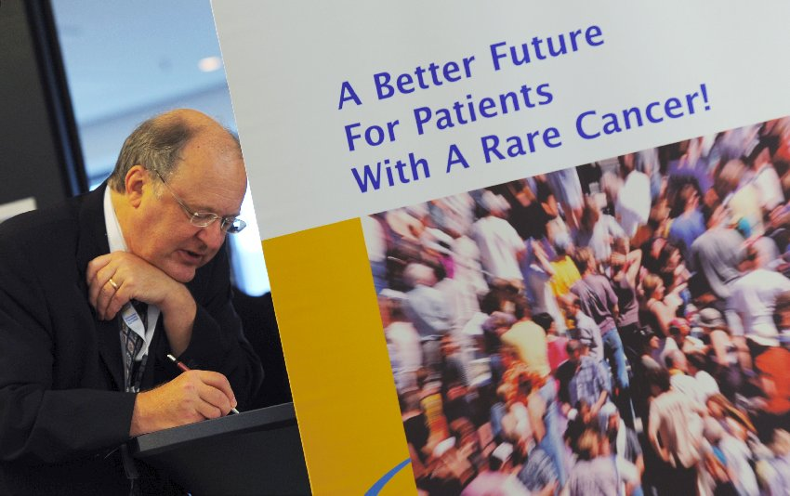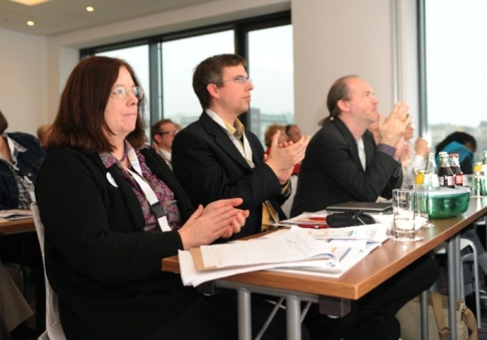
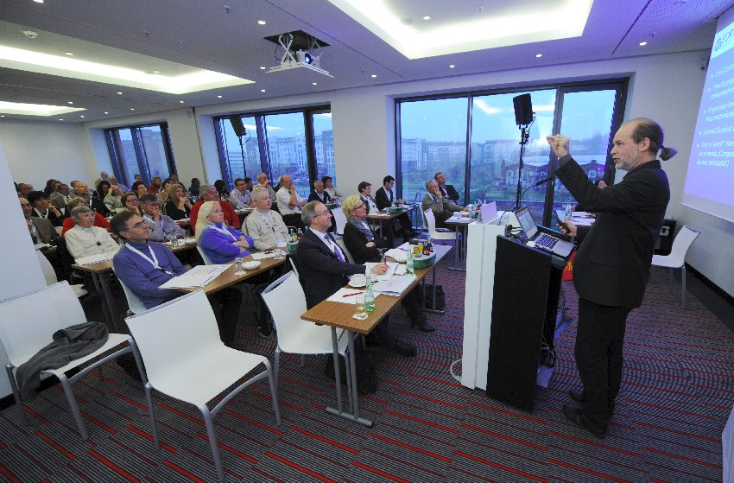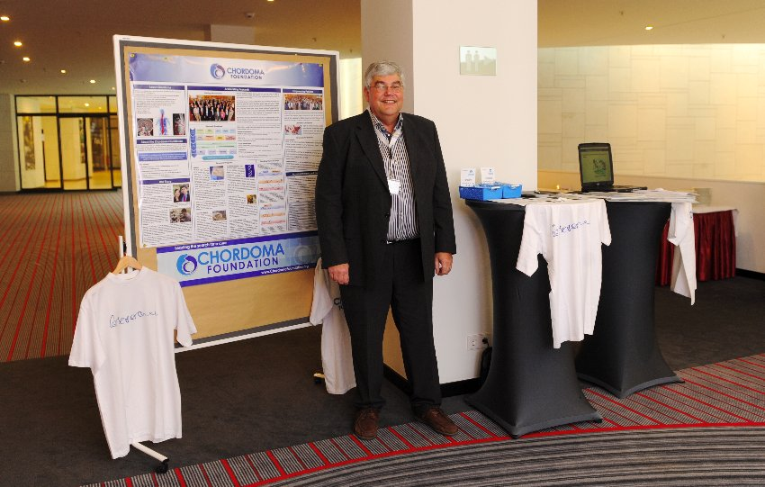
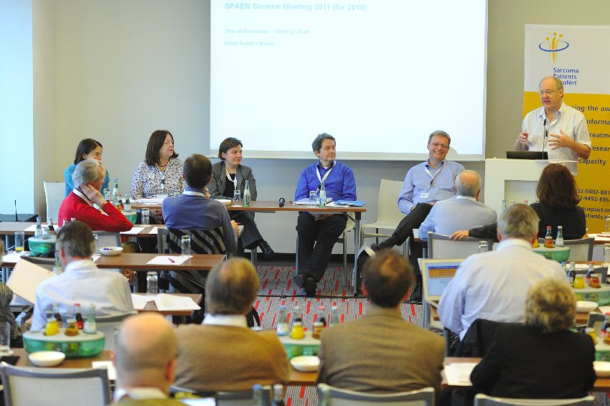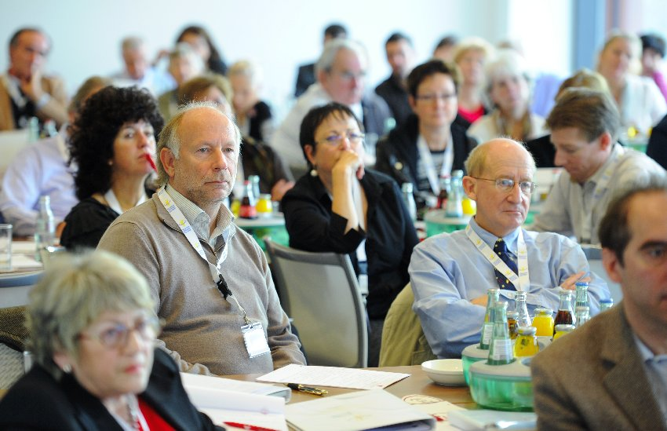
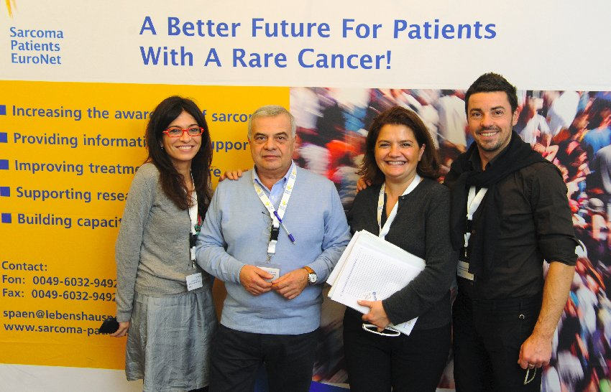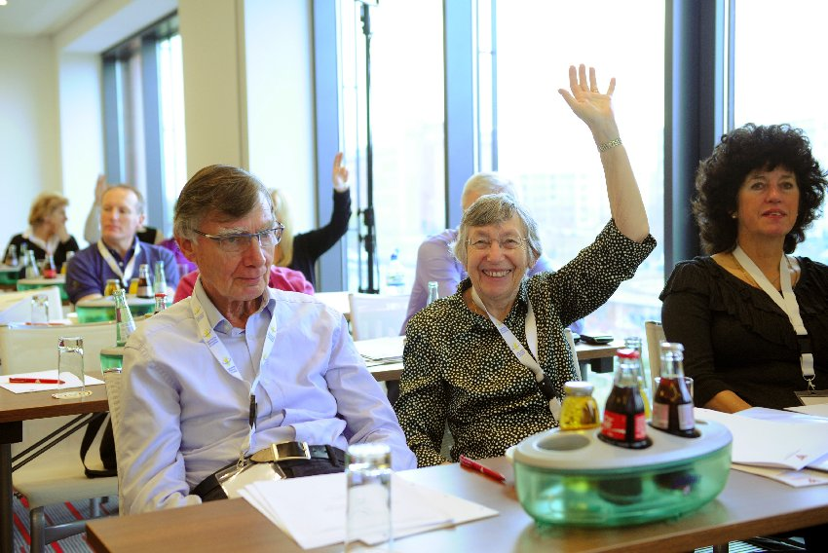

Agenda
2nd SPAEN Annual Conference for Organizations
Representing Patients With Sarcomas, GIST or Desmoid-Tumours

DAY 1 – THURSDAY November 17, 2011 > RESEARCH-DAY
12:30 L I G H T L U N C H (60 min.)
13:30 OFFICIAL START OF THE CONFERENCE
Main room – Plenary Sessions: JADE
13:30 - 14:00 | Opening, Welcome, Organizational Issues, Thanks to the Sponsors, etc.  Roger Wilson (SPAEN) & Markus Wartenberg (SPAEN)
14:00  14:30 | PFIZER and BAYER welcome SPAEN in Berlin:  Research-Strategy Pfizer Oncology and Pfizer’s commitment to the  Cancer-/Sarcoma Patient Community  Dr. Ivonne Marondel, Director Strategic Alliances, Pfizer , Germany  Bayer – Committed to Oncology  Dr. Dirk Laurent, Global Clinical Development Oncology,  Bayer HealthCare Pharmaceuticals, Germany
15:00 – 15:30 C O F F E E B R E A K (30 min.)
15:30 – 16:30  16:30 – 17:30 | Moderator: Barbara Dore (SPAEN)  Endpoints/patient related outcomes in Sarcoma-/GIST-/Desmoid-Trials.  Understanding the results in Sarcoma Trials.  Dr. Jan Bogaerts, EORTC Stats. Dept., Belgium  “Quality of Life” as a future endpoint in Sarcoma-/GIST-/Desmoid-Trials?  General evaluation of QoL and practical aspects for Sarcomas  Corneel Coens, EORTC Qualitiy of Life Dept., Belgium
B R E A K B E F O R E D I N N E R
19:30 - 22:00 | Internal dinner at the Sky Café of andel’s Hotel  Moderator: Estelle Lecointe (SPAEN)  Key Note Lecture:  The future roles of the “SARCOMA LEAGUE” and the WORLD SARCOMA NETWORK”  Prof. Dr. Jean Yves Blay, Université Claude Bernard in Lyon, France

DAY 2 – FRIDAY November 18, 2011 > TREATMENT-DAY
09:00 – 10:30 | Introduction: Understanding Sarcomas  Questions & Answers to an European Expert Panel  (Moderated sessions with prepared questions and questions from the audience)  Moderator: Roger Wilson (SPAEN)  Panellists: Prof. Dr. J.Y. Blay, Dr. D. Strauss, PD Dr. P. Reichardt
10:30 – 11:00 C O F F E E B R E A K (30 min.)
11:00 – 12:30 | Special issues in the surgery of Sarcomas:  - The surgical treatment of Retroperitoneal Sarcomas  Dr. Dirk Strauss, Royal Marsden Hospital, UK  - The role of surgery and reconstruction in Bone Sarcomas  Lee Jeys, The Royal Orthopaedic Hospital Oncology Service, UK
12:30 – 14:00 B R E A K L U N C H (90 min.)
14:00 – 14:45  14:45 – 15:30 | GIST Track  Room: JADE  Moderator:  Barbara Dore  The procedure of Mutational Testing in GIST and what are potential pitfalls  Prof. Dr. Florian Haller, Inst. of Pathology, Erlangen, Germany  Workshop: Compliance in GIST needs professional therapy- and side effect management  Estelle Lecointe |  | Sarcoma Track  Room: OPAL 2  Moderator:  Markus Wartenberg  The management of Advanced Sarcomas  Prof. Dr. J.Y. Blay,  Université Claude Bernard in Lyon, France  Update: New treatment options, agents and clinical trials in Sarcomas  PD Dr. Peter Reichardt, HELIOS Klinikum Bad Saarow, Germany | Desmoid Track  Room: AQUAMARIN  Moderator:  Christina Baumgarten  Molecular genetics and role of pathology  Dr. Agnes Neuville, Institut Bergonié, France  Surgical treatment of Desmoid Tumors  Dimosthenis Andreou, Sarkomzentrum Berlin-Brandenburg, Germany
15:30 – 16:00 C O F F E E B R E A K (30 min.)
16:00 – 16:45  16:45 – 17:30 | GIST Track  Moderator:  Jayne Bressington  Update on “Paediatric GIST”  Dr. R. Bulusu, Addenbrokes Hospital Cambridge, UK  New treatment options, agents and clinical trials in GIST  PD Dr. Peter Reichardt, HELIOS Klinikum Bad Saarow, Germany |  | Sarcoma Track  Short profiles of very rare Sarcoma Subtypes  - Chordoma  Lee Jeys  - Uterine LMS  Prof. Dr. J. Y. Blays  - Soft Tissue Sarcomas with involvement of the vessels: incidence, classification and therapy  Prof. Dr. Matthias Schwarzbach, Klinikum Frankfurt Höchst, Germany | Desmoid Track  Systemic treatment options for desmoids and current/ upcoming clinical trials  PD Dr. Bernd Kasper, UMM Mannheim, Germany
B R E A K B E F O R E DINNER
19:00 – 23:00 | External Dinner at “Spandau Brewery” (guided bus tour and dinner)
DAY 3 – SATURDAY November 19, 2011 > ADVOCACY-DAY
09:00 - 10:00 |  | Sarcoma Patients EuroNet Assoc. GENERAL ASSEMBLY 2011/2012  Additional INVITATION/AGENDA - for SPAEN Members only & invited guests  Chaired by SPAEN Board
10:00 – 10:30 C O F F E E B R E A K (30 min.)
10:30 - 12:30 |  | Round table discussions about access to clinical excellence (national needs, problems and challenges in terms of medical issues and treatment) and advocacy and patient group work  - Workshop Session I: Access to clinical excellence  (5-6 round tables for 30 minutes)  - Sharing Session I (30 minutes)  - Workshop Session II: Successful advocacy and patient group work  (5-6 round tables for 30 minutes)  - Sharing Session II (30 minutes)
12:30 – 13:30 L I G H T L U N C H (60 min.)
13:30 - 15:00 |  | Moderator: Michael Sayers (SPAEN)  Sharing best practice session  - The making of our GIST Film  Martin Wettstein & Helga Meier Schnorf, GIST Group Switzerland  - From support group to national charity – how Sarcoma UK has improved its support for patients by introducing professional staff  Lindsey Bennister, CEO Sarcoma UK  - Introduction of the newly founded organization Romanian Rare Cancers Association  Darko Emese, Romanian Rare Cancers Association  - How I started my Desmoid group  Elisa Baldoin, President Desmoid Italy  - The research stimulating efforts of the Chordoma Foundation  Hans Keulen, European Liaison Chordoma Foundation, US  - Ways of communication: How you let patients know that you are there to help them  Gabriella Tedone, A.I.G. Associazione Italiana GIST  - How we started and how we communicate with our patients  John Parkinson, The Sheffield Sarcoma Support Group, UK  - Ways to reach new patients and members-only forum  Ellen van Arem de Haas, Forum-Newsletter-Web-editor in chief Contactgroep GIST The Netherlands/ Belgium
15:00 - 15:15 |  | End of meeting, Summary, Feedback-Forms, Closing Remarks,  Thanks to the Presenters & Sponsors  Estelle Lecointe & Barbara Doré
15:15: OFFICIAL END OF THE CONFERENCE

Participants List
2nd SPAEN Annual Conference for Organizations
Representing Patients With Sarcomas, GIST or Desmoid-Tumours

1 | Dimosthenis | Andreou | Germany | Sarkomzentrum Berlin-Brandenburg
2 | Philip | Ashman | Germany | Bayer HealthCare Pharmaceuticals
3 | Jack | Asselbergs | NL | Contactgroep GIST Nederland
4 | Elisa | Baldoin | Italy | GIST-Group Switzerland
5 | Jane | Barrett | UK | Sarcoma UK
6 | Christina | Baumgarten | Germany | SOS Desmoid & SPAEN
7 | Lindsey | Bennister | UK | Sarcoma UK CEO
8 | Jayne | Bessington | UK | GIST Support UK & PAWS GIST
9 | Jean Yves | Blay | France | Université Claude Bernard, Lyon
10 | Jan | Boegarts | Belgium | EORTC
11 | Ramesh | Bulusu | USA | Addenbrokes Hospital, Cambridge
12 | Cameron | Burry | UK | Sarcoma UK
13 | Christina | Claussen | Germany | Pfizer
14 | Corneel | Coens | Belgium | EORTC
15 | Barbara | Dore | UK/USA | GSI GIST Support International/GIST Support UK & SPAEN
16 | Liesbeth | de Boer-Oosterhuis | Belgium | Pfizer bv
17 | Ilka | Einfeldt | Germany | GSK
18 | Darko | Emese | Romania | Romanian Rare Cancers Association
19 | Simona | Ene | Romania | HOPE SUPPORT GROUP FOR WOMEN WITH CANCER/ECPC
20 | Piotr | Fonrobert | Poland | Stowarzyszenie Pomocy Chorym na GIST
21 | Michaela | Geissler | Germany | SPAEN
22 | Franco | Gherlinzoni | Italy | Associazione paola per i tumori muscoloscheletrici
23 | Ornella | Gonzato | Italy | Associazione paola per i tumori muscoloscheletrici
24 | Florian | Haller | Germany | University Medical Centre Erlangen
25 | Michael | Hannah | UK | Sarcoma UK
26 | Davorin | Herceg | Croatia | Organization of cancer patients, families and friends „For a new day"
27 | Frode Dyrnes | Homb | Norway | Sarkomer Norway
28 | Vincenzo | Ippolito | Italy | Unit of Orthopedic Oncology and Sarcoma Unit;  Civil General Hospital, Brescia & Le Ali Onlus
29 | Peter | Jay | UK | Sarcoma UK
30 | Lee | Jeys | UK | The Royal Orthopaedic Hospital Oncology Service
31 | Maria | Julian | Spain | PharmaMar
32 | Peter | Kaskel | Germany | MSD SHARP & DOHME GMBH
33 | Bernd | Kasper | Germany | Mannheim University Medical Center
34 | Katarina | Katavic | Croatia | Organization of cancer patients, families and friends „For a new day"
35 | Hans | Keulen | NL | Chordoma Foundation
36 | Vera | Krstevska | Macedonia | GIST Patient Group Macedonia
37 | Dejan | Krstevski | Macedonia | GIST Patient Group Macedonia
38 | Małgorzata | Krzywicka | Poland | Stowarzyszenie Pomocy Chorym na GIST
39 | Dirk | Laurent | Germany | Bayer HealthCare Pharmaceuticals
40 | Estelle | Lecointe | France | A.F.P.G. "Ensemble contre le GIST" / Info Sarcomes & SPAEN

41 | Martina | Lehnert-Grimm | Germany | Novartis Germany
42 | Vanni | Lodi Rizzini | Italy | Aldo Arienti Amici C.O.O. Onlus
43 | Ivonne | Marondel | Germany | Pfizer
44 | Vanigli | Massimigliano | Italy | Desmoide Association Italy
45 | Audrey | Mathot | Switzerland | Gist Gruppe Schweiz
46 | Faisal | Mehmud | UK | GSK
47 | Helga | Meier Schnorf | Switzerland | GIST-Group Switzerland
48 | India | Minton-Barker | UK | Aggressive Fibromatosis Desmoid Tumour Information
49 | Daniela | Monfasani | Italy | Aldo Arienti Amici C.O.O. Onlus
50 | Georges | Moreau | France | SOS Desmoïde
51 | Arron | Mungul | UK | GSK
52 | Agnes | Neuville | France | Institut Bergonié in Bordeaux
53 | John | Parkinson | UK | Sheffield Sarcoma Support Group (affiliated to Sarcoma UK)
54 | Matilde | Penas | Spain | PharmaMar
55 | Sylvia | Petak-Opel | Germany | MSD SHARP & DOHME GMBH
56 | Francesca | Piccolo | Italy | Le Ali Onlus Association
57 | Kai | Pilgermann | Germany | Das Lebenshaus e.V.
58 | Peter | Reichardt | Germany | Helios Klinikum Berlin
59 | Philippe | Rigaux | France | SOS Desmoid France
60 | Judith | Robinson | UK | GIST Support UK
61 | Michael | Sayers | UK | GIST Support UK & SPAEN
62 | Matthias | Schwarzbach | Germany | Klinikum Frankfurt Höchst
63 | Yukari | Seki | Germany | Bayer HealthCare Pharmaceuticals
64 | Andrew | Sheppard | UK | Bristol Sarcoma Support & Bone Cancer Research Trust
65 | Victoria | Smith | UK | Sarcoma UK
66 | Dirk | Strauss | UK | Royal Marsden Hospital
67 | Inka | Talvitie | Finland | The Association for Finnish Cancer Patients
68 | Gabriella | Tedone | Italy | A.I.G. Associazione Italiana GIST Onlus
69 | Hugo | Teixeiro da Silva | Germany | Bayer HealthCare Pharmaceuticals
70 | Geraint | Thomas | UK | GSK
71 | Paolo | Tomassone | Italy | A.I.G. Associazione Italiana GIST Onlus
72 | Spiros | Tzivelekis | Germany | Bayer HealthCare Pharmaceuticals
73 | Jutta | Ulbrich | Germany | Bayer HealthCare Pharmaceuticals
74 | Ellen | van Arem de Haas | NL | Contactgroep GIST Nederland
75 | Laurens | van Bavel | NL | Contactgroep GIST Nederland
76 | Louisa | van Dun | NL | Contactgroep GIST België
77 | Mirja | Voutilainen | Finland | The Association for Finnish Cancer Patients
78 | Anna | Wallace | UK | Living Beyond Diagnosis
79 | Markus | Wartenberg | Germany | Das Lebenshaus e.V. & SPAEN
80 | Martin | Wettstein | Switzerland | GIST-Group Switzerland
81 | Jasmine | Whittaker | UK | Desmoid patient
82 | Roger | Wilson | UK | Sarcoma UK & SPAEN
83 | Terence | Yap | UK | Takeda Europe
84 | Andrew | Yates | UK | Sarcoma UK
85 | Avi | Zigdon | Israel | The Israeli GIST patients organization
86 | Tamar | Zigdon | Israel | The Israeli GIST patients organization

SPAEN Membership

SPAEN welcomes every Sarcoma, GIST or Desmoid Patient Group/Organisation in Europe as Full Member. Full Members are entitled to vote at the Annual General Assembly. All other PAGs from outside Europe are welcome to join SPAEN as Associate Members.
Among the benefits of membership are: information exchange with other members, receiving SPAEN newsletters and briefings, an invitation to SPAEN’s annual meeting, mention of your organisation on our website, and finally, as part of a united international sarcoma community we all have a better chance to have our voices heard.

SPAEN Full Members

- Finland: Finnish GIST Patient Network
- France: A.F.P.G. "Ensemble contre le GIST"
- France: Info Sarcomes
- France: SOS Desmoide France
- Germany: Das Lebenshaus e.V./House of Life
- Germany: SOS Desmoids
- Italy: A.I.G. Associazione Italiana GIST
- Italy: Le Ali Onlus
- Italy: Luogo di incontro per scambiarsi informazioni sul tumori Desmoide o Fibromatosi agressiva
- Italy: Associazione Paola per i Tumori Muscoloscheletrici. Onlus
- Macedonia: Patient Advocate from Macedonia
- Netherlands: Contactgroep GIST
- Poland: Stow. Pomocy Chorym Na GIST
- Poland: Stow. Pomocy Chorym Na Miesaki "Sarcoma"
- Romania: Romanian GIST-Network
- Sweden: GIST Sverige
- Switzerland: GIST Gruppe Schweiz
- UK: GIST Support UK
- UK: Sarcoma UK

SPAEN Associate Members
- USA: GSI - GIST Support International
- USA: Sarcoma Alliance
- USA: Chordoma Foundation
- USA: The Liddy Shriver Sarcoma Initiative

About Sarcoma Patients EuroNet

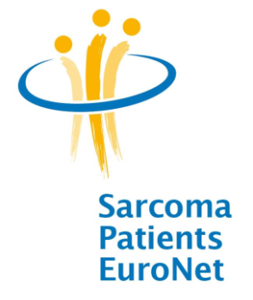
Sarcoma Patients EuroNet Association (SPAEN), the European Network of Sarcoma, GIST and Desmoid Patient Advocacy Groups, was founded in April 2009 with the aim of extending information services, patient support and advocacy to patient organisations for the benefit of sarcoma patients across the whole of Europe. 11 foundation members initiated the foundation of SPAEN and membership is open to patient groups working with sarcoma patients across Europe. SPAEN is an European association – legally registered under German law.

Acting in partnership with clinical experts, scientific researchers, industry and other stakeholders SPAEN is working to improve the treatment and care of sarcoma patients in Europe through improving information and support, and by increasing the visibility of sarcoma with policymakers and the public. SPAEN currently has 21 members from 13 countries.
Vision
- A Better Future For Patients With A Rare Cancer.
- Speaking with one voice at European level, advocating and cooperating professionally and in partnership; to create a better future for Sarcoma patients and their families in every nation.
- Acting in partnership with experts, the researching industry and other stakeholders SPAEN will work to improve treatment and care of sarcoma patients in Europe through improving information and support, and by increasing the visibility of sarcoma with policymakers and the public.
Core Values
- Focused on the needs of the PAGs (patientadvocacy groups) and the patients/caregiver
- Willingness to advocate
- High quality of information/education/training (correct, up to date, understandable, independent)
- Cooperative and professional
- Ethical, transparent, behave with integrity
- Innovative spirit
The main objectives of SPAEN are:
- Increasing the awareness of GIST, Desmoids and other sarcomas
- Providing information and support
- Improving treatment and care
- Supporting research
- Building capacity

Sarcoma Patients EuroNet e.V./Assoc. is supported by leading “European Sarcoma Experts (Expert Groups)” and the pan-European collaboration of sarcoma specialist researchers and doctors, Conticanet. In 2010 Sarcoma Patients EuroNet has established an Medical Advisory Board with a high level of scientific expertise.

Medical Advisory Board
Sarcoma Patients EuroNet has established an Medical Advisory Board with a high level of scientific expertise. The objectives of the Medical Advisory Board is to support SPAEN in:
- gaining legitimacy within the European and International community of experts involved in Sarcoma, GIST and desmoïd tumours;
- ensuring patient representation in, and integration to, major scientific committees and groups of experts at national and European levels.
The following 12 experts are appointed as members of the SPAEN Medical Advisory Board (2010 - 2013):
Name | Field | Country/City | Expert-Group
Prof. Dr. Jean Yves Blay (Chair) | Oncology | France/Lyon | GSF GETO
Prof. Dr. Javier Martin Broto | Oncology | Spain/Palma | GEIS
Prof. Paolo Casali | Oncology | Italy/Milano | ISG
Prof. Dr. Jean Michel Coindre | Pathology | France/Bordeaux | GSF GETO
Prof. Dr. Mikael Eriksson | Oncology | Sweden/Lund | SSG
Prof. Dr. Robert Grimer | Surgery | UK/Birmingham | BSG
Dr. Allessandro Gronchi | Surgery | Italy/Milano | ISG
Prof. Dr. Peter Hohenberger | Surgery | Germany/Mannheim | GISG/KO.SAR
Prof. Dr. Ian Judson | Oncology | UK/London | BSG
PD Dr. Peter Reichardt | Oncology | Germany/Berlin | GISG
Prof. Dr. Pjotr Rutkowski | Surgery | Poland/Warsaw | POLSG
Dr. Beatrice Seddon | Oncology | UK/London | BSG

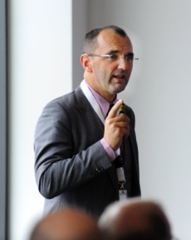
Prof. Dr. Jean Yes Blay (EORTC President and Director of Conticanet) who is chair of the SPAEN Medical Advisory Board states: “Sarcoma Patients EuroNet is a very welcome development. We need to involve patients in clinical trials at the design stage so that the relevance of what we do can be considered at the outset. In addition SPAEN will be valuable helping patients understand what being treated in a clinical trial could mean to them. Together we can complete research more quickly and introduce new treatments faster.”

SPAEN Board of Directors and Officers
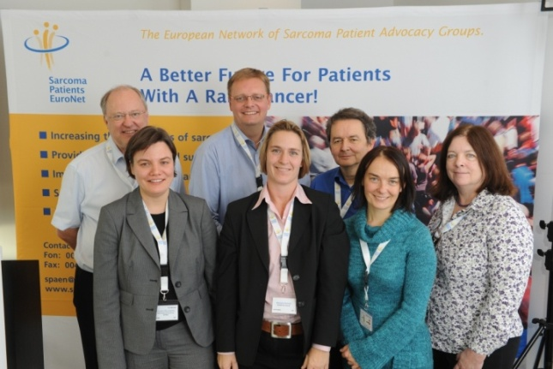

The current members of the SPAEN Board of Directors (2010 – 2013) are:

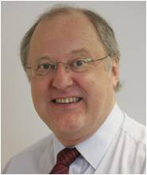  Roger Wilson, President (UK)  Sarcoma UK | 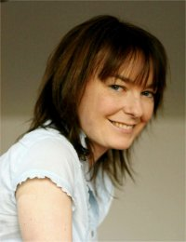  Estelle Lecointe,  Vice President (France)  I'A.F.P.G. "Ensemble contre le GIST" & Info Sarcomes
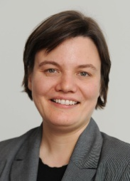  Christina Baumgarten,  Vice President (Germany)  SOS Desmoid | 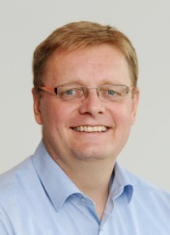  Markus Wartenberg,  Financial Director (Germany)  Das Lebenshaus e.V.
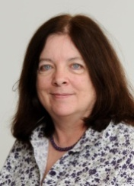  Barabara Doré,  Secretary (UK/USA)  GIST Support UK & GIST Support International | 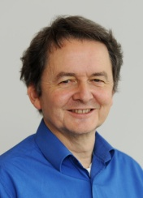  Michael Sayers,  Board Member (UK)  GIST Support UK

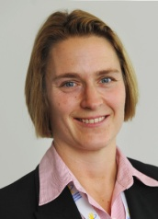
Michaela Geissler
SPAEN Project Manager (SPAEN Secretariat)

Contact
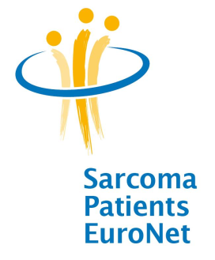
Sarcoma Patients EuroNet e.V./Assoc
SPAEN Administration Office

Mrs. Michaela Geissler (Project Manager)
Am Rothenanger 1B
D-85521 Riemerling, Germany
Tel.: + 49 89 62836807
Fax: + 49 89 62836808

Email: info@sarcoma-patients.eu
Web: www.sarcoma-patients.eu

SPAEN is registered as an association under German law in Friedberg/Germany -
Registration-No. VR 2609

Registered office/legal venue:
Sarcoma Patients EuroNet e.V./Assoc
Usa-Straße 1
61321 Bad Nauheim/Germany

